IFGA Sanctioned Shows
Show Entry Registration Guide Original: 2010-2011
Charlotte Kelley Michigan Guppy Breeders August, 2011
Updated and augmented October 2017 by
Greg Billings New England Fancy Guppy Association

Table of Contents
IFGA Show Entry Registration Guide

Preparation for the Show 3
Recording Entries 4
Printing Exhibitor's Entries 6
Entry ID Bowl Stickers 7
Record Entry Fees 8
Registration Closed 8
Class Count 8
Placement Bowl Stickers 8
Entering Judging Results 8
Lists for Auction, Awards Cards and Award Plaques 9
Printing Final Results 9
Announcement of Winners 10
Plaques and Award Cards Distribution 10
Send Final Results to be Published 10
Check List for Registration Table 10
Equipment List and Supplies 11

IFGA Show Entry Registration Guide

Preparation for the Show
There are a number of details to attend to before the first day of the show that will allow the registration process to go smoothly.
- Go to the IFGA Show Section to download the registration program, labels and judging cards. Don’t use last year’s down loaded file because it will NOT have the latest list of breeder names preloaded. Check with the show chairperson, they may have a newer version sent to him/her that hasn’t been posted yet with an updated breeder list preloaded. Change the file name to refer to your show! Make sure the latest file version is installed on the computer being used at the show. Also have a copy loaded on a backup drive such as a flash or external drive that will also be used at the show.
- Carefully read the instructions for the registration program which is the first worksheet of the workbook labeled “Instructions” and colored green. It is recommended to practice by using past results from a previous show to become familiar with the program. If you do, strongly suggest that you rename it immediately with “Test” or “Practice” in the title so you don’t corrupt the original.
- Review the checklist of equipment and supplies needed at the end of this guide and purchase necessary supplies.
- Print labels and judging cards before show.
  - Bowl Stickers
    - Microsoft Word (Avery label 05422, 0.5” X 1.75” label)
    - MS Excel using (Avery label 8160 or 5160, 1” X 2.625” label)
  - 1st thru 4th Place Stickers in Microsoft Word (Avery label 05472)
  - Print judging cards on heavier stock paper (Judging cards in Microsoft Word). Add the name of club hosting the show and date on each page as a footer. It will be necessary to change the bottom margin.
- Have sign-up sheets for judges, assistant judges and observers. Advise each exhibitor about the sign-up sheets.

First some discussion about the terms we’ll use in this guide for the MicroSoft Excel IFGA show registration file so that we are all on the same page. The whole file you downloaded from the web site is called a “workbook”. Inside it, there are multiple “worksheets” which are also called “tabs”. Inside of each worksheet (tab) are thousands of cells. Each cell has it’s own format, formula and text. A cell is defined by its column then row. For example, Cell A1 is in column A, first row. In this example, the highlighted cell is C6 (Gold F5), third column, and 6th row.
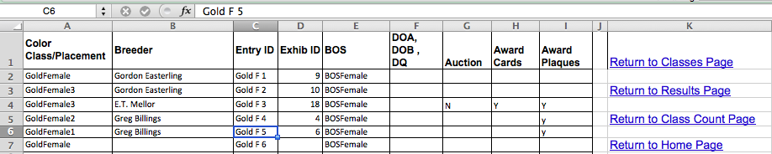
Tabs (worksheets) are near the bottom of your window as shown in the screen capture below. These tabs have been color-coded using the colors of a stoplight.
- Red for STOP… DANGER! Look but Never alter the text/format in these tabs
- Yellow for CAUTION… read/use but don’t alter.
- Green for GO… Type where directed with some caution of course

The “For Printing (add judges & DQs)” worksheet is a great example of a green tab where you are expected to do some typing but you must be cautious. The only changes that should be made there are …
- Add the official name of the IFGA show in cell A1 (column A, row 1)
  - Never merge cells with A1 or alter its format
- Add the date of the IFGA show in cell A3 (Column A, row 3)
- Add the full judges, assistant judges and observers in the designated sections at the bottom (… and admin or Breeders if you want)
- Never change any of the actual show results on the “Results” or “For Printing” tab. If you notice something is wrong with the results, use the actual judging cards data to alter the individual class in question within the class tab.

Recording Entries times as entries are being made – exterstick)
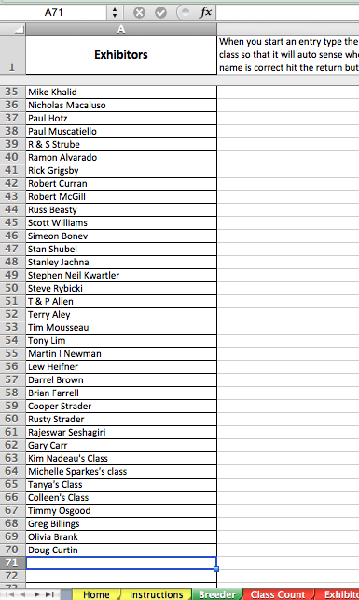
Using the Official Entry Form, register all the exhibitor’s fish listed on the form. (Exhibitor should have two completed copies of the form.) Routinely backup the whole registration workbook to a flash drive or other storage device in addition to the original on your computer hard drive.
To register the entries:
- Open the Breeder tab. Type the name of exhibitor/breeder if it hasn’t been already preloaded at the bottom of column “A” in the cell just below the last name listed. Cell A71 in this example. (This will put a copy of the name of exhibitor/breeder on each color class page.) Be careful to be consistent with the spelling of each exhibitor’s name. As a reference, use the IFGA’s web Show Section, Show Points, and Point standings to identify the proper way to identify the breeders that have been participating in the present show season. If a name is misspelled, it will have to be corrected manually using the “find/replace” command but make sure you use it for the whole workbook and not just the worksheet. Remember that if you only correct it on the breeder tab (worksheet), it won’t change any breeder misspellings that were recorded previously in the individual class worksheets (tabs).
- Click on the green colored “Classes” tab or the “Color Classes” option on the “Home” tab. Click on the color class to enter all fish in that class. Use links on the right side of each color class page to Return to Classes Page to choose another color class to enter. Continue to do this until all of the breeder’s entries are completed. (Also enter their bag label, auction, award card and plaque information found on their official entry form.)
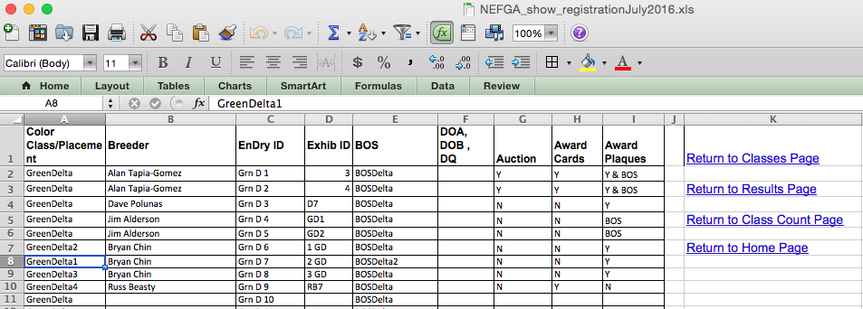
- Column A – Color Class/Placement: Choose classes to enter all exhibitors’ fish in that particular color class (Green Delta in above case).
- Column B – Breeder: Enter name from the drop down menu when you click in the next empty cell. Notice in the sample below, by just typing the letter “G”, four names popped up. Glide down with your cursor to the appropriate name to auto fill the “B7” cell.
- 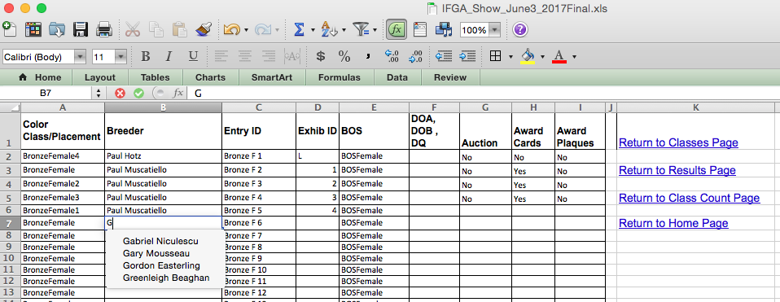Column C – Entry ID: Uses the corresponding entry ID tag to give to the exhibitor/breeder to put on bowls using the next available ID.
- Column D – Exhib ID: Enter exhibitor’s bag number if provided. The bag number is useful for cross-referencing, if problems occur, to identify exhibitor/breeder’s entry.
- Column E – BOS: Will be entered after judging of all classes is finished and the BOS place takers are determined.
- Column F: The DOA, DOB, DQ will be entered after fish have been determined to be DOA, DOB or DQ. These have to be put in manually.
- Column G – Auction: Enter fish that are to be auctioned after judging. Put X in column. Some clubs use “Y” or “N” so every cell is filled to confirm that the auction details were checked.
- Column H – Award Cards: The exhibitor specifies on the entry form, “Please award cards”. Put an X in column if the exhibitor does want cards. Some clubs again use the “Y/N” entry scheme.
- Column I – Award Plaques: The exhibitor specifies on the entry form, “Please award plaques”. Put an X in column if the exhibitor does want plaques. Some clubs again use the “Y/N” entry or “BOS only”
After all entries are recorded on the color “classes page”, choose Return to Home on the far right or click on the “Home” tab.

Printing Exhibitor’s Registered Entries
To print out the exhibitor’s entries, choose Exhibitor Entries tab. In Breeder tab, cell “C1” note that there is an icon in lower right corner. Click on that icon to get a drop down menu to choose the next exhibitor’s name. (If the drop down menus does not work, select the row header, then choose tools, then protect/unprotect). Make certain the drop down menus are checked “Show All”. In this example, we last filtered for “E.T. Mellor”. By the way…Never “Sort” …. always “filter”.

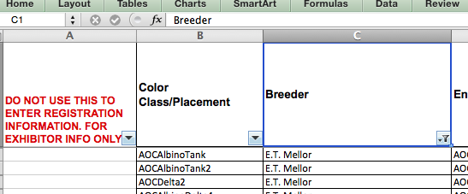
The filter pop ups below show the changes you’ll have to make. Click on “select all” then click on it again to NOT “select all” (toggles all on then another click toggles all off).
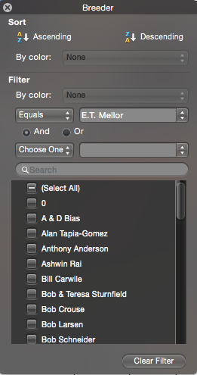Select all- 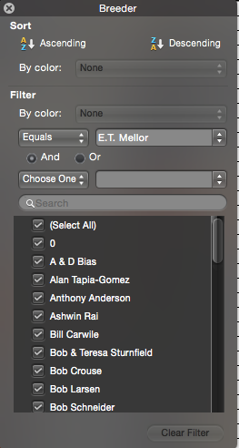Deselect all 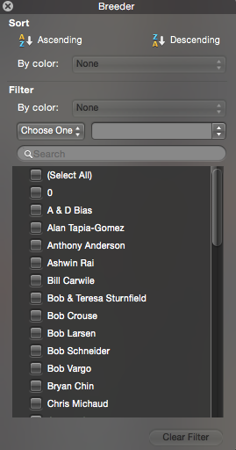
In the pop up menu, scroll down to the next person to print… say “Greenleigh Beaghan” to list her entries next. Each click will change the breeders on the screen but the end result will be the following…. Greenleigh’s entries!
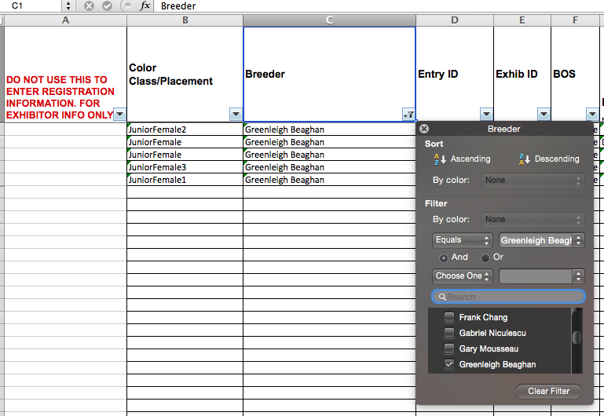

Highlight the area to print (file/print area/clear/set print area). I clicked on cell “J6” and dragged to “B1” to cause the blue highlighted area as seen below. As a rule I usually click on the bottom cell farthest to the right that I want and drag to the top cell farthest to the left that I want to print so as to include the column headers.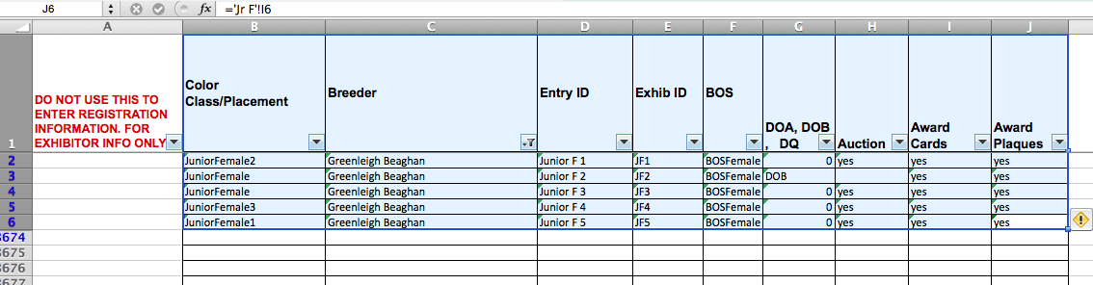Print two copies. (If there are fish for auction, print an extra copy for the auction team leader which will include the Entry ID tag for easy retrieval and ensure the correct fish is entered into the auction.) Also, changing the size of the font (12 or 14) makes the registration sheet easier to read for the exhibitors. (Choose the tool box to change size of font and to center the X in the auction, award cards, and award plaques columns.) The printed registration copy should agree with the list of entries on the exhibitor’s official entry form. Have a second person double check the entries against exhibitor’s official entry form and if necessary make corrections at this time.

Return to Breeder tab to enter the next breeder’s entries.

Entry ID Bowl Stickers
Paper clip one copy of the exhibitor’s entries and one copy of the registration sheet together with the entry fees. Insert the second copy of the exhibitor’s form and the second copy of the registration sheet (back to back) into the plastic sheet protector and attach the entry ID bowl sticker labels to the plastic sheet protector. Pass one set to person putting on the labels and the other set to the cashier.

Record Entry Fees
The cashier will verify entry fees received against exhibitor’s official entry form. Keep one set of the forms for the club’s records and the other set for the exhibitor. Let exhibitor know fish are ready to bench.

Registration Closed
When registration is closed do not delete unused rows in the new program. Prepare for judging of entries to begin.

Class Count
Open the Class Count tab and print out number of entries. These numbers are entered on the judging cards. Add the number of entries for each class from the class count sheet to each judging card. The judges will count the number of entries on the bench before they begin judging and compare to each judging card. Usually one of the observers will assist with this task. If the number is different on the judging card determine the error, correct and return judging card to judges.

Placement Bowl Stickers
Bowl Stickers for 1st, 2nd 3rd and 4th are given to judging teams to use as the judging is in progress. DOA, DQ, DOB bowl stickers are also available. These labels are printed out prior to show.

Entering Judging Results
Go to appropriate class. In the "Color Class/Placement" Column A, put a "1,2,3,or 4" after the class name. It needs to be exactly this way (no space after the words) for the program to find the 1st, 2nd, 3rd and 4th place winners. In the example above, “Grn D 7” was in first place on the judging card so, a “1” was added to “GreenDelta” in cell A8 to read “GreenDelta1”. “Grn D6” was second so, a “2” was added to “GreenDelta” in cell A7 to read “GreenDelta2”. The signed judging card had “Grn D 8” as 3rd place so a “3” was added to “GreenDelta” in cell A9 to read “GreenDelta3”. Finally, “Grn D ” was in 4th place so a “4” was added to “GreenDelta” in cell A10 to read “GreenDelta4”. “This task is easier to enter the number in the formula bar. Notice in the example, cell A8 was clicked on so it is highlighted in blue and “GreenDelta1” is in the formula bar where the “1” was added.
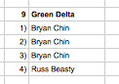
If all was entered correctly, Excel will auto fill the “Green Delta” section of both the “results” tab and the “For Printing” tab with the appropriate names and the class count “9” in this example.
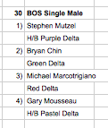
For BOS winners use the "BOS" Column E and use a similar format but they also have to be exactly as follows: For Delta/Single use...BOSDelta1, BOSDelta2, BOSDelta3, BOSDelta4. For Tank use...BOSTank1, BOSTank2, BOSTank3, BOSTank4. For Female use ... BOSFemale1, BOSFemale2, BOSFemale3, BOSFemale4. These labels are printed out prior to show. Notice that in our Green Delta screen shot on the previous page, “Grn D 7” placed first in the class but it also went on to place 2nd in Best Of Show Delta. Thus in Column E the “BOSDelta” had a “2” added on the end (NO SPACES) to read “BOSDelta2”. In this example, note that Excel then auto-entered the breeders name AND the class into the “Results” tab and “For Printing” tabs under the BOS Single Male section at the top of the worksheets. These results should NEVER be entered on the two “Results” sheets… make sure the judging card data entered correctly auto-fills this data.

While judging is in progress go to the Results tab to verify the judging cards are being recorded properly and the transferring of names from your registration page is properly being recorded. On the “For Printing” tabs, add the name of club and date of show… never on the “Results tab. Remember, the “Results” worksheet’s tab is RED for a reason… STOP! …Look but don’t touch!!!!

Lists for Auction, Awards Cards and Award Plaques
Select the Exhibitor Entries tab to print out lists for auction, awards cards and plaques, use the dropdown menu in each column to “show all”. Filter each of the three columns separately. You could also do this manually, taking the information off each exhibitor’s official entry form, to make a hand written list or to use as a cross-reference to the printed copy. Before filling out an award card, check the list of exhibitors that do not want award cards or plaques. As judging is finished for each class, the award cards can be filled out using the information written on the judging card. Volunteers may help fill out these cards. Alphabetize the cards. Have the cards available for exhibitors to pick up on Saturday night or Sunday.

Printing Final Results

The “For Print” sheet prints out a three-page report to hand out to exhibitors and to put into shipped-in-entry boxes when packed for return. You are expected to do some typing but you must be cautious. The only changes that should be made there are …
- Add the official name of the IFGA show in cell A1 (column A, row 1)
  - Never merge cells with A1 or alter its format. Text will auto flow into B1
- Add the date of the IFGA show in cell A3 (Column A, row 3)
- Add the full judges, assistant judges and observers in the designated sections at the bottom (… and admin or Breeders if you want)
- Never change any of the actual show results on the “Results” or “For Printing” tab. If you notice something is wrong with the results, use the actual judging cards data to alter the individual class in question within the class tab.
Before printing, enter the names of judges, assistant judges and observers on the final “For Print” page manually. Determine number of copies needed for show handouts and mailing with shipped in entries. Print as many as you can AND make sure they get into the hands of the people at the show… the more eyes that see it, the better your chance of catching any errors.

Announcement of Winners:

Post the final results before the hospitality time for those attending the show. As mentioned before, use this precious time to have all view so that any errors that can be caught, can be corrected

Plaques and Award Cards Distribution:
Determine the exhibitors that want plaques and award cards. Using the final results pages, assemble the “labels”, 1st, 2nd, 3rd, 4th, Best of Show, etc. for each exhibitor that placed. Arrange the awards and plaques in alphabetical order for exhibitors to pick up.

Send Final Results to be published:

Send your final show results to be published on the IFGA website as soon as you have finalized it to: IFGA web master, points chairperson, and the Judging Board chairperson. You can send the show results in any form to the judging board chair but the points chairperson and the IFGA web master need the entire registration file in the MS Excel format.

Check List for Registration Table:
- Download Show Entry Registration program from the IFGA web page before going to the show. Go to the IFGA Show Section to find the files that are used for a show. Test the down loaded program to assure the program is set up to work on your computer.
- Purchase supplies needed:
Avery labels 05422 and 05472. Print the labels for the ID tags. It is helpful to have the labels organized by Delta, Tank, Veil, Female, Novice, Junior, and Breeders. (Use removable labels that will peel off after being stuck to tanks). The NEFGA uses Avery Removable 1 x 2 5/8 Inch White ID Labels Avery#6460 which are much larger thus easier to work with our older fingers. Not only will the removable labels make it easier to clean/pack up the tanks at the end of the show BUT ALSO they are more easily placed on the bags when you box the fish.
If you are interested in getting the MS Excel file to print the larger #6460 labels, contact Greg Billings via the NEFGA website.
- Paper (8 ½ x 11).
- Heavier stock paper for judging cards if you want. However, many clubs use the same standard paper for judging “cards”.
- Plastic protector sheets or gallon storage bags to insert exhibitors’ registered entries.
- Print out rules for show to have available at the registration table. Have a printed list of exhibitor’s name for spelling consistently when registering entries and writing the award cards. Using the IFGA Show Points list for the year would be a handy reference. If you have the time after the registration process is done, simply print out the list of names from the “Breeders” tab of your shows registration file.
- Venue - tables and chairs for workers, table coverings, extension cords & surge protectors for computers. Make sure your extension cord is long enough to get you to an outlet.
- Club - have at least three to four core people for registration. The registration team will do the following tasks:
  - Data entry person to enter and print out exhibitor’s entries, (Enter shipped in entries first and keep separate). Print two copies, one to attach to the original and one for the exhibitor. A third copy can be printed for the auction team leader.
  - Assistant to read entries to data entry person. Put the printed registered entries into plastic protector sheet. Confirm the printout entries are the same as the exhibitor’s official entry form including auction and awards and plaques.
  - Person to adhere bowl entry ID stickers to plastic protector sheet.
  - Cashier to confirm entry fee and record amount and inform exhibitor they can bench their fish. Many clubs also have this person generate a file with all the breeder’s contact info and funds sent.
  - Track the exhibitor’s that want to auction fish and do not want award cards and plaques. A list can be printed after registration is finished.
  - Add number of each class to judging card. (Print Color Class sheet for this information.)
  - Award cards are filled out as judging is being completed. Volunteers usually help. Cards can be alphabetized and ready to display on table for pick up Saturday evening or Sunday morning and paired with the plaques. This saves on mailing costs.

Equipment List and Supplies:
Computer with registration program downloaded
Printer
Second computer and all-in-one printer for back up
Extra ink cartridge for back up
Flash drive for back up
Cables and cords for computer and printer
Power strip
Electrical cord
Extra Exhibitor’s Entry Forms
IFGA Approved Classes list and Show Rules
Stapler and extra staples
Paper Clips
Scissors
Scotch tape
Extra ink pens for sign-up sheets and award cards
Permanent markers
Cash Box for cashier, extra cash to make change
A sign “make check payable to MGB”
Clipboards for judges
Sign up sheet for special events, etc.
Sign up sheets for judges, assistant judges and observers
Award cards and plaques

NOTES:

